Check TCP Listening Port in Windows

1. Extended object (*port_sensor_windows.nsh*) source code

|  |
| --- |
| #!/bin/nsh  nexec $1 netstat -na|egrep "LISTENING|Proto"|sed 's/:/ /g' |

2. In Object Dict

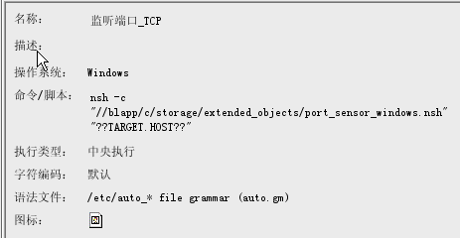

3. In Live view

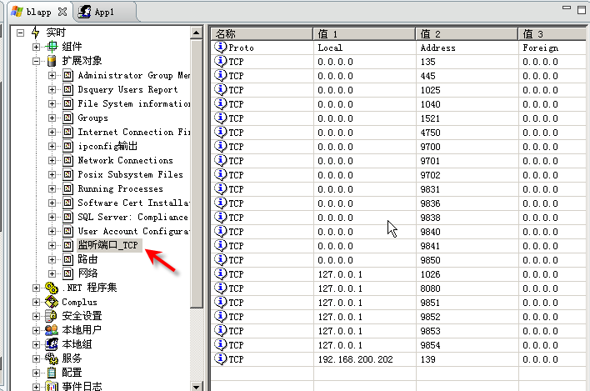

4. Rules

